**Dialog map**

This the main user interface dialog map. It consists of three sub activity: customer home page, vendor home page, admin home page.

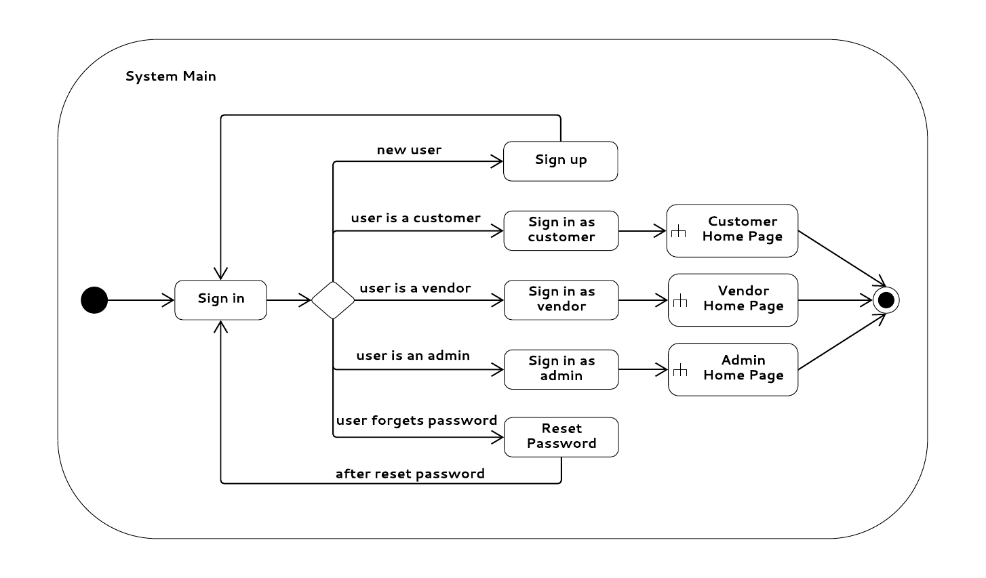

This is the vendor home page.

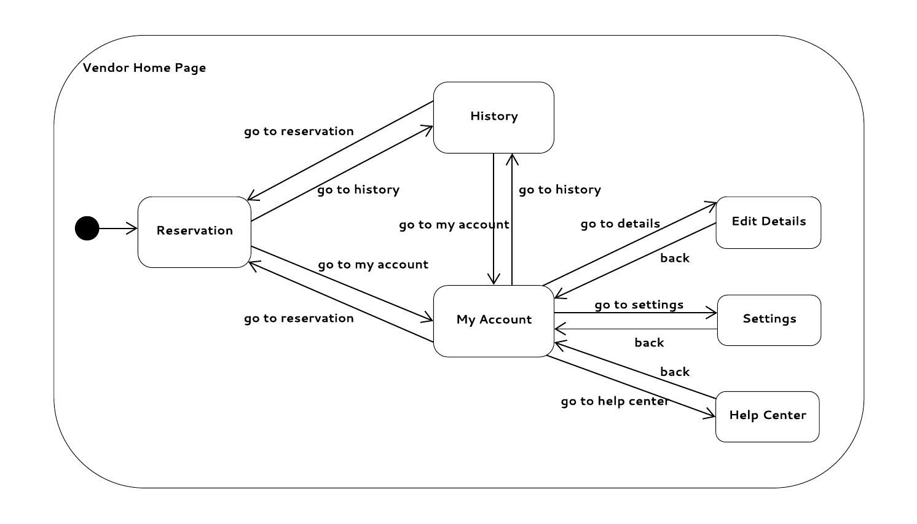

This is the administrator home page.

